CLASS ACTIVITY 2B LECTURE 19

Table Name Shipper:

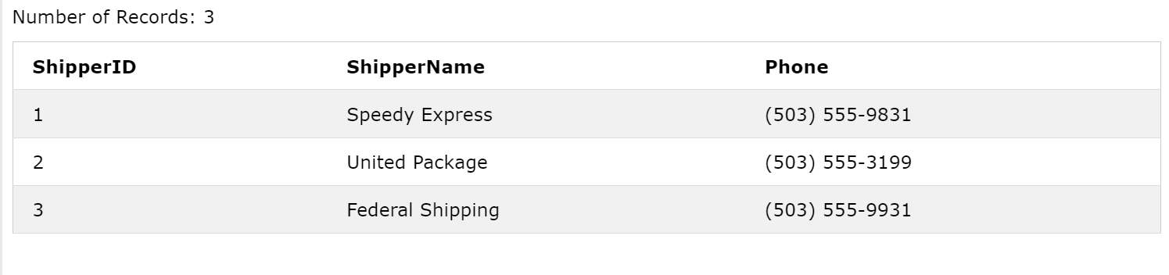

1. Insert a new record shipper name =’your name’ and phone number to ‘your number’ in above database.
2. Delete the record with shipper id 1.
3. Update the record with shipper id 1 to your friend’s name and phone number.
4. Arrange your records according to shipper name in descending order.